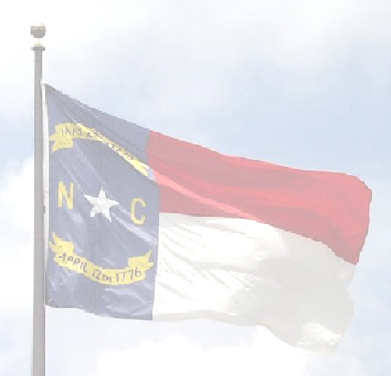
Robeson County Board of Elections
Post Office Box 2159
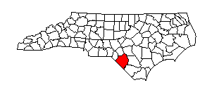
Lumberton, North Carolina 28359

Robeson County Board of Elections Mailing
800 North Walnut Street PO Box 2159 Lumberton, NC 28358 Lumberton, NC. 28359
Larry Townsend, Chairman (910) 671-3080 Phone
Gretchen Lutz, Secretary (910) 737-5094 Fax Marion Thompson, Member Director Tim Heath, Member Tina M. Bledsoe
Patricia Dow, Member

NOTICE

March 17 ^{tH}, 2025

THE regularly SCHEDULED BOARD MEETING FOR
TUESDAY, MARCH 18th, 2025 AT 6:00 P.M.
HAS BEEN CANCELED,
DUE TO NO PERTINENT BUSINESS TO COME BEFORE THE BOARD.
NEXT SCHEDULED BOARD MEETING IS
TUESDAY, APRIL 15TH, 2025 AT 6:00 P.M.

Tina m. Bledsoe - Director

