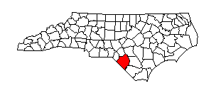
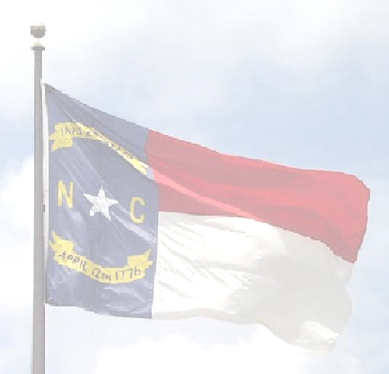
Robeson County Board of Elections
Post Office Box 2159
Lumberton, North Carolina 28359

Office
Robeson County Board of Elections 800 N. Walnut Street
Larry Townsend, Chairman Phone
Gretchen Lutz, Secretary (910) 671-3080
Marion Thompson, Member Fax
Patricia Dow, Member 910-737-5094
Tim Heath, Member Director
Tina M. Bledsoe

ROBESON COUNTY BOARD OF ELECTIONS
September 17th, 2024
Notice of Cancelled Meeting

The Robeson County Board of Elections has cancelled their Regularly Scheduled Board Meeting, that is scheduled to be held on Tuesday, September 17th, 2024 at 6:00 p.m., due to No pertinent business to come before the board.

The next scheduled meeting will be an Absentee Board Meeting, scheduled to be held on Tuesday, October 1st, 2024.at 6:00 p.m., at the office of the Board of Elections. Located at 800 North Walnut Street, Lumberton, NC. 28358.
If cancelled, the next scheduled absentee meeting will be held on October 8th, 2024 at 6:00 p.m.

Any questions or remarks, please contact the office at 910-671-3080, during business hours. Monday-Friday 8:15-5:15 p.m.

Tina M. Bledsoe, Director
800 North walnut Street
Lumberton, NC. 28358
(O) 910-671-3080
(F) 910-737-5094
Tina.bledsoe@robesoncountync.gov

